**Analytics Components:**

1. Analytics Summarizer

2. Compactor

3. Reducer

4. Carrier Summarizer

5. Wurfl Device Summarizer

6. Data Migrator

**Analytics Data Flow:**

Analytics Reducer

Analytics Master DB

Analytics reduce DB

Analytics Compactor

Analytics temp DB

ZestADZ Shard DB

Analytics Summarizer

**Analytics Summarizer:**

* This component will run every 5 minutes.
* This component will process hourly data.
* Reads data from ZestADZ Shard DB and will write it back to “analytics temp DB” up on successful transaction.
* On transaction failure, data will rollback to ZestADZ Shard table.
* It uses **analytics transactions** table for maintaining the **state of previous transactions**

Note:

4 instance of analytics summarizer is enough to carry out the task. Running too many instances may result in “too many connection error”

**Compactor:**

* This component will run once in every 4 hours.
* This component will process data based on record ids @ one shot it will process 750000 records.
* Max record process can be changed in settings.rb.
* It reads data from “Analytics Temp DB” and will write it back to “analytics reduce DB” up on successful transaction.
* On transaction failure, data will rollback to temp tables.
* It uses **compactor transaction** table for maintaining the **state of previous transactions**

**Reducer:**

* This component will run once in every 4 hours.
* This component will process data based on record ids @ one shot it will process 750000 records.
* It will process data only for yesterday records.
* Max record process can be changed in settings.rb.
* It reads data from “Analytics Reduce DB” and will write it back to “Analytics master DB” up on successful transaction.
* On transaction failure, data will rollback to reduce tables.
* It uses **reducer transaction** table for maintaining the **state of previous transactions**

**Carrier Summarizer**

This component will run once in an hour.

It reads data from temp_adv_carriers table in analytics_temp_db and write it back to owners table in analytics_reduce_db.

It process data for every previous hour and date while executing.

It does not have any transaction table to maintain the state

Note:

It is highly recommended to synch owners table in analytics_reduce_db and analytics_master_db to avoid “Unknown carrier” issue (once in a week).

Steps:

1. Right click on reduce_analytics database and select “Export database as SQL”
2. Uncheck all the tables except owners, analytics_wurfl_devices and analytics_wurfl_capabilities table
3. Click on Destination tab and check Data option and select “Insert new data (do not update existing)” option and select Another Database option and select zestadz_analytics database
4. Click on Export button.
5. Repeat the above steps for “Update existing data” option also.

**Wurfl Device Summarizer**

This component will run once in an hour.

It reads data from temp_adv_devicesproperties table in analytics_temp_db and write it back to analytics_wurfl_capabilities & analytics_wurfl_devices tables in analytics_reduce_db.

It process data for every previous hour and date while executing.

It does not have any transaction table to maintain the state

This component is being used for device properties chart.

Note:

It is highly recommended to synch analytics_wurfl_capabilities & analytics_wurfl_devices tables in analytics_reduce_db and analytics_master_db (once in a week).

**Issues and Maintenance**

Deleting older data

Error occurred while reading or writing data into analytics table

**Deleting older data from temporary analytics table:**

1. Check Analytics_summarizer status, whether it is running or sleeping.
2. If sleeping, stop all the analytics instance(kill the component)
3. Wait for compactor_transaction to process and move all the temporary table data to reduce database. Normally it will take 2 to 3 hours based on the time
4. Ensure the above steps by running following queries against temporary database:
   1. select * from compactor_transaction order by id desc limit 20

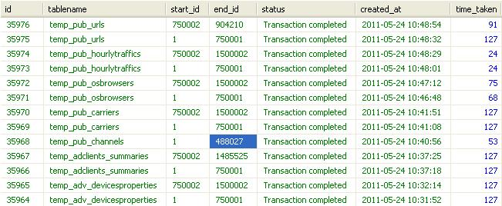

* 1. select * from temp_adclients_summaries order by id desc limit 10

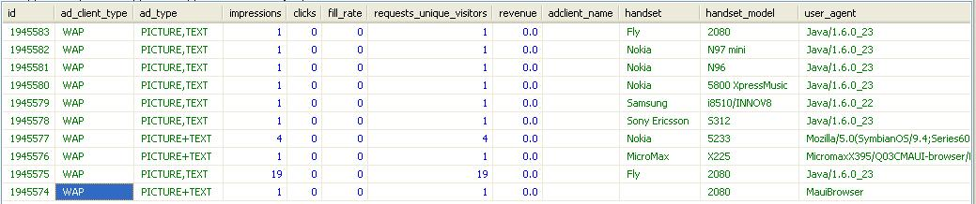 c. Should match if the data have been processed from temporary to reduce database.

d. Please repeat the above step and ensure data has been processed for all the tables.

5. Upon successful process of all the temporary data, truncate the temporary analytics tables.

6. Delete the records except zero record from compactor_transaction table as below:

select * from compactor_transaction order by id asc limit 20

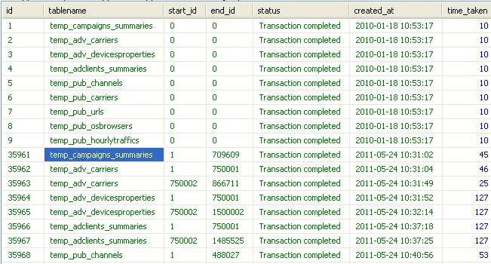

Now delete the records using following queries:

Delete from compactor_transaction where id>9

7. Start the analytics_summarizer components.

**Error occurred while reading or writing data**

1. Check the email for error message and time.
2. Ensure the same in component console.
3. Based on the error message troubleshoot the issue by removing or updating the unnecessary data

**No Records in analytics table**

General tips:

This issue can occur due to the failure of analytics components.

Ensure all analytics components are up & running.

Check for error if any.

Solution:

1. Check whether data is present in analytics reduce database
2. If present then resolve the issue at reducer level
3. Else if not present, check whether data is present in analytics temporary database
4. If present then resolve the issue at compactor level
5. Else if not present, Check whether data is present in shard tables.
6. If present then
7. Check email and analytics summarizer console for error
8. Check whether “temp_database_config.yml” and “master_ database_config.yml” settings are correct
9. Ensure data in analytics_transaction table are correct and status are correct.